Constraints
What are Constraints?
Constraints are defined as conditions upon which a project must be managed against which can negatively affect budget, quality, schedule and scope.
Some typical constraints might include a lack of:
Money
Skilled resources
Requirements for the project
Equipment
Management support
Time
Even though the above constraints are important to the success of a project, Project 2010 cannot account for these constraints. However, the constraints Project 2010 can help you with are dates.
Tasks may require a target date or start at a specific date, end at a specific date, or require scheduling at the beginning or ending of a timeframe.
Date constraints can be used to refine the project schedule when greater control is needed for specific tasks start or finish dates. Using date constraints, however, will also remove flexibility from the schedule. It is for this reason that the use of constraints be kept to a minimum. Some of the date constraints are more flexiable than others available. The flexible constraints will be the most beneficial during scheduling.
Manual Scheduled tasks can not use contraints. They are used for Auto Scheduled tasks only.
Constraint Types
Constraints are used when a task must be scheduled with a specific date in mind or within a specific time period. When setting constraints, the following pieces of information must be known:
Constraint type
Date for the constraint
There are 8 constraint types available in the Project 2010 and all are date dependent:
As Soon As Possible (ASAP) - default constraint applied to all tasks when a project is scheduled from the project start date. Tasks will be scheduled as early as possible within a timeframe.
As Late As Possible (ALAP) - default constraint applied to tasks when a project is scheduled from the finish date of the project. Tasks will be scheduled as late as possible within a timeframe.
Finish No Earlier Than (FNET) - applied to a task that must finish no earlier than a specified date. The constraint date will be applied to the finish date of the task and the task will move forward in time to the date specified for this constraint.
Finish No Later Than (FNLT) - applied to a task that must finish no later than a specified date. During tracking, tasks will move forward in the schedule. Tasks with Finish No Later Than constraints will move forward and stop at the constraint date.
Start No Earlier Than (SNET) - applied to a task that must start no earlier than a specified date. The constraint date will be applied to the start date of the task and the task will move forward in time to the date specified for this constraint.
Start No Later Than (SNLT) - applied to a task that must be started by a specified date. During tracking, tasks will move forward in the schedule. Tasks with a Start No Later Than constraints will move forward and stop at the constraint date.
Must Start On – applied when a task has a hard start date. The task will move to the constraint date and is fixed on that date.
Must Finish On - applied when a task has a hard finish date. The task will move to the constraint date and is fixed on that date.
To Add a Task Constraint
Method 1
Double-click any cell in the desired task row to launch Task Information.
Click the Advanced tab
In the Constraint type drop-down list, choose the desired constraint
In the Constraint date field, enter or choose the desired date (optional)
Click OK
If the planning wizard appears because you are creating a constraint on a task with a link to another task, you must select: Continue. A XX constraint will be set. Any of the other choices will alter or cancel the constraint type you selected.
To Remove a Task Constraint
Method 1
Double-click any cell in the desired task row to launch Task Information.
Click the Advanced tab
In the Constraint type drop-down list, choose As Soon As Possible
Click OK
The Constraint date will be automatically cleared.
As Soon As Possible is for schedules calculated from a Project Start Date.
Method 2
Highlight cell with either the Start or Finish date
Press the Delete key
This method is typically used when you accidentally enter in the Start or Finish fields
Warning - If you do not have a predecessor link to a task and remove a constraint, the task simply moves to the start of the project and you may lose information related to the desired date for the task. Be sure to create the appropriate links first.
Avoiding Accidental Constraints
The project manager creates constraints when entering a constraint type and date for a task. Constraints can be created in other ways as well, often accidentally.
The most common mistake made in Project is entering dates on auto-scheduled tasks directly in the Entry table portion of the view so that task constraints are created. Unnecessary constraints make it extremely difficult to manage project schedules, and track and update activities within your project.
Constraints on auto-scheduled tasks are set when you do any of the following:
Enter or select from the date picker pop-up a Start Date directly in the Entry table.
Enter or select from the date picker pop-up a Finish Date directly in the Entry table.
Drag a Task Bar in the bar chart left or right.
By setting constraints, you effectively lock those tasks from moving in the future. As your project progress has an ebb and flow of activity that takes the timeline forward or backward, these tasks will remain unmoved and unmovable, and will tend to bring up error messages.
If a Start date is entered for an Automatically scheduled task, a Start No Earlier Than constraint will be applied to the task. If a finish date is entered a Finish No Earlier Than constraint will be applied.
When working with constraints you may be prompted with a Planning Wizard message. These messages are optional can be turned off individually or globally as desired.
How to Disable the Planning Wizard Messages
Method 1 – Disable an Individual Message
In the Planning Wizard dialog box that appears, click Don’t tell me about this again.
Method 2 – Disable All Messages
Click the File tab
Click Options
Click Advanced in the Project Options dialog box
Uncheck Advice from Planning Wizard
You can use this process to enable groups of messages that you individually disabled.
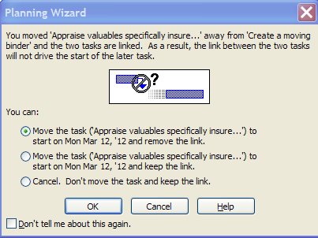
PLACEHOLDER
If Planning Wizard messages are turned off, you will not be alerted to possible scheduling errors that might be created as a result of creating a constraint or other scheduling issues.
You may also notice smart tags appearing in cells as you work with constraints. You may click the drop-down arrow next to the caution indicator to review available options.
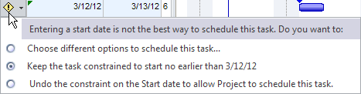
PLACEHOLDER
Selecting an option (even the suggested one by Microsoft Project) may alter your previously applied constraint.
Best Practice: If your scheduling style is to enter dates on each task, it is recommended that you use a manual scheduling approach instead of automatic scheduling. This will allow for tasks to be scheduled to the dates entered and will not be subject to the automatic scheduling engine of the software. If a task is scheduled using manual scheduling, the tasks can be changed to automatic scheduling at any time.
Constraints will also be entered as a result of the tracking process which will be discussed in a future module.
Effects of Constraints
Constraints may cause errors in the scheduling of a project that are not readily apparent. Refer to the example below.
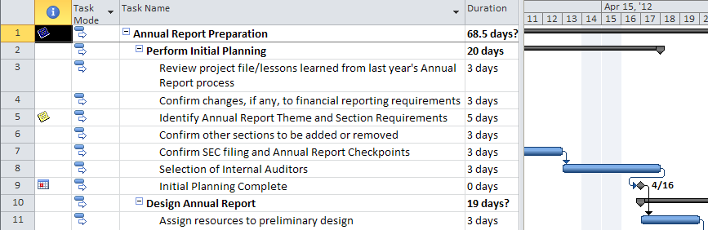
PLACEHOLDER
There is an error in the calculation of the date for the task 9 “Initial Planning Complete”. The relationship line after task 8, “Selection of Internal Auditors” flows backwards in time. The reason for this is that task 8 is scheduled to complete on April 17, one day later than the milestone target date of April 16. Tasks that are dependent on task 9 will also be miscalculated.
Monitoring for date calculation errors in your schedule is important.
Best Practices:
Constraints should be used sparingly.
Do not enter a constraint based on a random target date. All constraints should have a purpose and a reason why they are created. If you feel you must use constraints or enter start or finish dates for most of your tasks, manual scheduling might be your scheduling style.
Deadlines
Task Deadlines
Deadlines represent a finish date goal or objective for a task. Using a deadline on a task will still allow it to flow with changes to the schedule and will not restrict its start or finish date like a constraint will.
Use deadlines over constraints to eliminate pop-up error messages when planning or executing your schedule.
A project manager should use deadlines to mark targets in the schedule and to provide simple visual cues when a deadline is missed.
To Set a Task Deadline:
Double-click any cell in the desired task row to launch Task Information.
Click the Advanced tab
In the Deadline field, choose or enter the desired date
Click OK
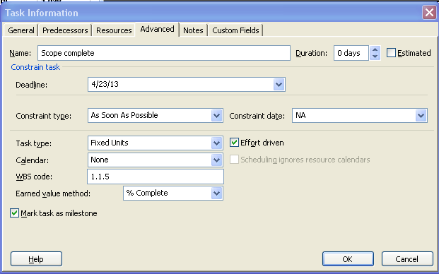
PLACEHOLDER
Refer to the following scenarios to further understand deadlines.
A deadline of April 23, 2013 has been assigned to the “Scope Complete” task below. The deadline is represented by the green arrow on the Gantt Chart and does not appear in the Indicator column.
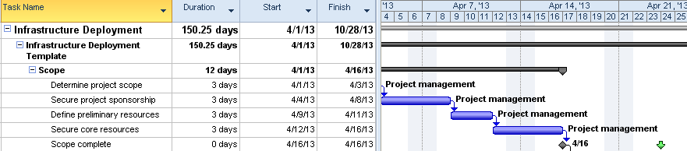
PLACEHOLDER
During project execution and tracking of the schedule, tasks will move forward in time. If a task with a deadline moves beyond the deadline arrow, the task will be considered late. Below is an example of the warning that will appear in the Indicator column if a deadline is not met. Notice the red diamond in the indicator column explaining that the task date has exceeded the deadline date.
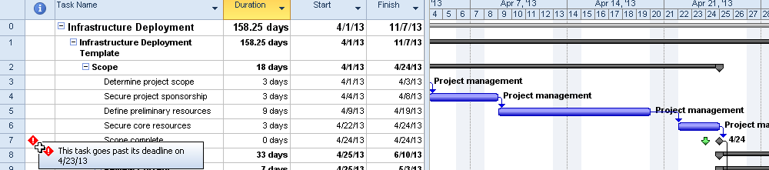
PLACEHOLDER
Another indicator to watch would be the Total Slack column. A negative value indicates that tasks are late and have missed or exceeded the deadline. The negative value indicates how many days the deadline was missed by. It is also an indicator of the amount of recovery time required to get the project back on track.
The Total Slack field provides information on auto scheduled tasks.
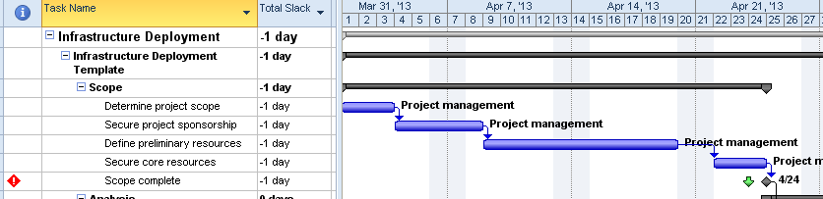
PLACEHOLDER
Unlike constraints, do not create date calculation errors in the schedule. Instead, they provide a visual indicator which flags you when deadline targets are missed.
Deadlines can be used in both manual or automatic scheduling mode.
To Remove a Task Deadline
Double-click any cell in the desired task row to launch Task Information.
Click the Advanced tab
In the Deadline field, select the date and press Delete
Click OK
Best Practices:
Substitute deadlines for constraints when possible.
Place deadlines on milestones to help manage short term goals. As long as the deadlines stay on the left side of the milestones, you are doing well.
If a deadline date has been exceeded, check the Total Slack column or indicators column on auto scheduled tasks to see how much time needs to be made up to get back on schedule.
Split Tasks
Splitting Tasks
There will be times during project scheduling that will require an interruption of work for a particular task. For example when planning a task, some of the work will occur on Monday and the remainder will occur on Monday the following week. In this situation two tasks could be entered or creating a split task would also work. Split tasks are designed for scheduling tasks that start then stop and start again.
When to use split tasks:
When the work of a long task is required to work around other tasks. Some of the work would be done before a hard date and the remaining portion of the work would be scheduled after the hard date.
Splits tasks may be used to help even out the resource work load
100% of the work for a task is not required to be performed without interruption and could be broken up over time.
To Split a Task
Click the Task tab
Click the Split Task icon
Position the mouse pointer in the middle of the Gantt bar for the desired task
Click and drag to the right until the desired split is achieved
PLACEHOLDER
Refer to the following tips and guidelines regarding task splitting.
Repeat the above steps to create additional splits
Both auto and manually scheduled tasks can be split.
Hover the split task mouse pointer over the Gantt bar of the task to be split.
The screen below will show the information box that will appear.
As the mouse pointer is dragged the length of the Gantt bar, the date will change in the box. Clicking the mouse pointer will split the task and leave a gap between tasks.
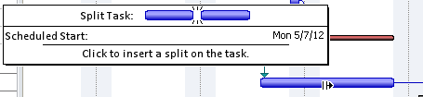
PLACEHOLDER
If the schedule has used “day” durations of tasks as the default scheduling increment, the gap in the split task will advance in 1 day increments or 1 week increments if “weeks” was used. A split task is shown in the view below.
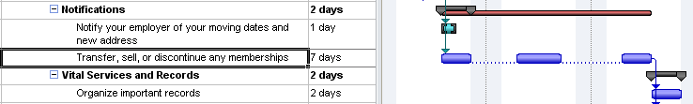
PLACEHOLDER
The dots between the sections of the task are the split task indicators showing that the task has been split. The individual parts may be dragged back and forth as necessary to achieve timeframes that will work best for the task. Drag the pieces back together will eliminate the split status for the task.
To Unsplit a Task
Position the mouse pointer on the left side of a right most bar segment
Drag the segment to the left until it connects to the bar segment
Repeat the above steps to reconnect additional segments if needed
There are a few rules, however that you should be aware of when working with split tasks:
When a task is split, it is still one task and will be treated as such.
Relationships will be applied to the beginning and ending of the entire split tasks only and not to the individual pieces. The individual parts are not separate tasks and cannot have discrete relationships.
When resources are assigned, the work will be distributed over the total task duration and task as a whole.
Constraints are applied to the start or the finish of the entire task and cannot be applied to the individual parts.
The parts of the task may be dragged back together when needed.
Tasks may be split multiple times.
Splitting will refine the workload and the duration of the task.
Hiding bar splits will conceal separations of a task and may create confusion when the task duration does not match the Gantt bar length of the task.
Split bars will occur during the tracking process to represent a task which stopped and restarted or a period of inactivity.
Task Calendar
Applying Task Calendars
There will be times when a task must occur within a unique timeframe and outside of the project calendar parameters. In order to accommodate such instances, users can create a distinctive calendar that can be assigned to a task. In doing so the task will be scheduled in the unique timeframe and not affect the scheduling of the entire project.
Below are some examples of when a task calendar would be used:
Testing at a bank can only occur after the bank is closed 9pm to 6 am
A weekend cut over of a software package or upgrade
Testing of a product that requires a 24/7 test
A task that must occur on second shift
Task applied to an resource in an alternate time zone
The first step in using task calendars is creating the calendar using the same process described in Module 2 to create a base calendar. After the calendar is created, it then may be applied to task. The resources assigned to the task will also be required to work in the unique timeframe. There is an option to ignore the resource calendars and allow the scheduling of the resources to be directed by the task calendar for the specific task only.
To Assign a Calendar to a Task
Double-click any cell in the desired task row to launch Task Information.
Click the Advanced tab
In the Calendar drop-down list, choose the desired calendar
If desired, click Scheduling ignores resource calendars
Click OK
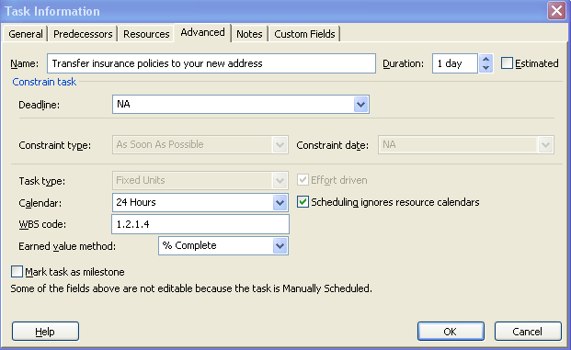
PLACEHOLDER
A visual indicator will appear in the Indicator column in the Gantt chart view.
PLACEHOLDER
Task calendars may only be applied to automatically scheduled tasks or manually scheduled tasks.
Move Project
Moving the Entire Project Timeline
Typically a project start date might change between the time the project is planned and the project actually starts. There are several methods available to change the project start date. It is important that the tasks are re-scheduled to adjust to the new start date.
The easiest way to change the project start date is use the Project Information box. Changing the start date using this method will move all tasks without entered dates or constraints to be rescheduled as of the new start date.
To Change the Project Start Date
Click the Project tab
Click Project Information in the Properties group
In the Start date field, enter or choose the desired new date
Click OK
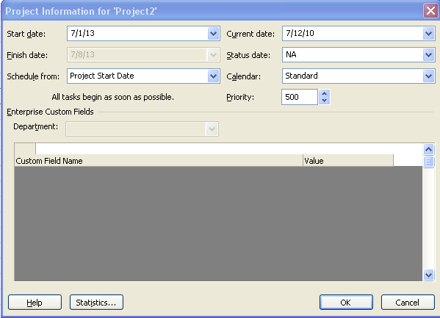
PLACEHOLDER
Changing the project start date will not reschedule tasks which have entered dates or constraints. Project 2010 provides a function called Move Project which will move all of the tasks to the new project start date. When tasks with constraints are moved using this function, the constraint dates will be adjusted based on the new project start date.
For example: if a task has a constraint 3 months from the start date of the project and the project start date is moved 6 months the constraint date will be re-scheduled 3 months from the new project start date.
The Move Project function also has an option to move project deadlines. If this option is not selected, the Deadlines will remain at the orignial dates and will need to be udpated manually.
To the project start date and move tasks with dates to a new timeframe:
To Move a Project
Click the Project tab
Click Move Project in the Schedule group
In the New project start date field, enter or choose the desired new date
Click Move deadlines
Click OK
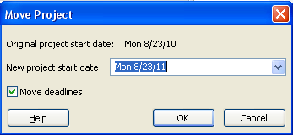
PLACEHOLDER
Any task that is not already linked in the schedule will move to the new start date that you enter using either of the methods above.
When you start a project as either a blank schedule or from a template, changing the project start date is recommended as a first step. If your project is fully planned out and has any type of task-related locked dates including deadlines or constraints, moving the project is recommended. This is especially useful when funding for a fully planned project has been delayed.
Task Notes
Adding Notes to Tasks
Each task has a freeform notes field. This field has no character length limitations, allowing for very detailed task notations. The notes field may contain several types of information such as objects, hyperlinks, bulleted lists, etc. Notes may be printed on reports, exported to Excel and may be used as needed throughout the life of the project schedule.
To Add a Task Note
Method 1
Double-click any cell in the desired task row to launch Task Information.
Click the Notes tab
Enter the note
Click OK
Method 2
Select any cell in the desired task row
Click the Task tab
Click Task Notes in the Properties group
Enter the note
Click OK
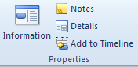
PLACEHOLDER
The notes view for a task is shown below:
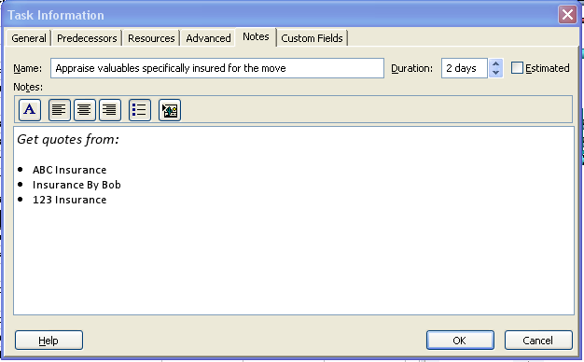
PLACEHOLDER
The Indicator column provides a visual indicator that a task note exists. Hovering the pointer over the icon will display the note preview to give the reader an idea of its content.
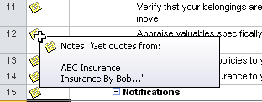
PLACEHOLDER
Notes can be invaluable and should be used during the planning and execution of the project. After the project is completed and a post-project review is conducted, task note information will help in recalling details of what occurred during the performance of tasks.
Best Practice: Although the software allows users to insert images, documents and other objects and files into the notes, users should avoid doing so as it will significantly increase the file size. It is better to insert references or links to where the user can find associated and relevant files.

